LAB-2 ASSIGNMENT

ENGLISH to ITALIAN translator (Android Application)

In this application, we have developed an android application that converts English to Italy. In this project we have created login page that contains username and password using those details user logs into the application. when he enters the correct details he will be redirected to the activity page where he enters the English word that needs to be translated into Italy. when he clicks on the translate now button a message will be shown with the translated word. A logout option is provided to end the activity.

STEP-1(login) STEP-2(translate page)

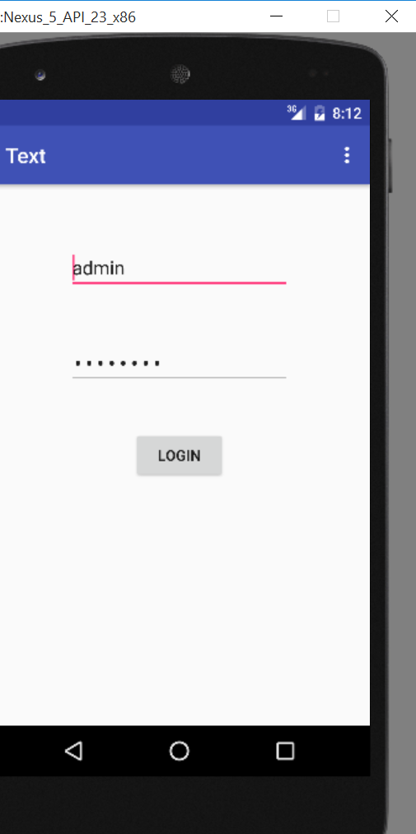 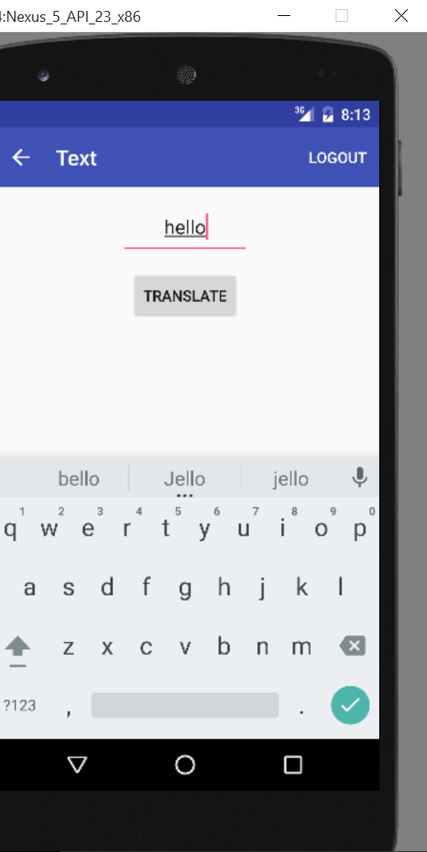

Step-3(done translation)

